Register Now!!!
Jingle Jolly Joy!
“Christmas Extravaganza”
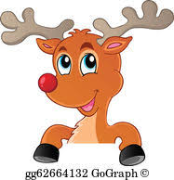
Become part of the Christmas Magic by performing in this Whimsical Rockette Style Christmas Show!

DON’T MISS OUT…REGISTER NOW!!!

Deadline to Register: Thursday, October 19th
(see back for details & registration form)
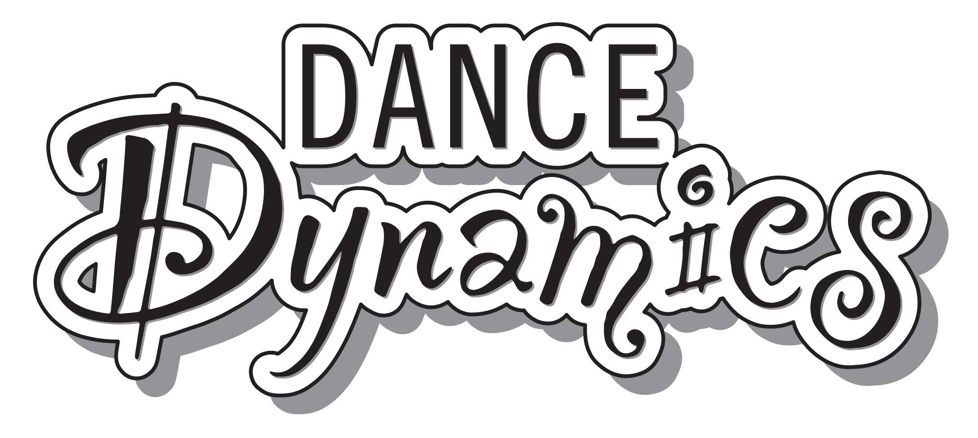
Jingle Jolly Joy!
Choreography Rehearsals
The dancers will learn the choreography during their normal weekly classes!

Dress Rehearsal
Saturday, December 2nd @ Bellevue East High School

Performance
Sunday, December 3rd @ Bellevue East High School

Cost
Theatre Rental Fee: $75/family (includes 4 tickets to the show)
Costume Fees:
-The Star That U R Classes: $75/each
-Raising the Barre Classes: $85/each

Please Note: In order for your costume(s) to be ordered, the following 4 items must be received by Thursday, October 19th:

October Tuition must be paid in full (This includes any past due fees)

The $75/family non-refundable theatre rental fee

The non-refundable costume fee(s)

The signed recital consent form found at the bottom of this sheet
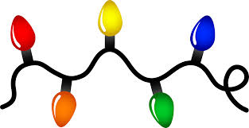

Dancer’s Name: __________________________________________________________

Please check which classes that you would like to participate in (Please Note: Combo classes will only be learning one Christmas routine):
_____Baby Stars * Rising Stars * Shooting Stars
_____Shining Stars
_____Sparkle Hip Hop * Boys Hip Hop Petite/JR * Hip Hop Petite/JR
_____Ballet JR/Teen & Ballet Teen/SR
_____Petite Ballet/Tap * Petite Ballet
_____Clogging Petite/JR * Clogging JR-SR
_____Clogging Adult
_____Tap JR/Teen * Tap SR
_____Hip Hop JR/Teen * Hip Hop Teen/SR

Total: $__________
_____Yes, apply my fundraiser credit to Jingle Jolly Joy if applicable: - $__________
_____No, save my fundraiser credit for Studio 2 Stage if applicable
Amount Due: $_________
Method of payment: Cash____ Check____ Credit/Debit Card____ Use Card On File_____

_____Yes, I plan to participate in the 2023 Jingle Jolly Joy Christmas Extravaganza. I understand that the fees are non-refundable. I also understand that costumes are non-returnable. If I decide NOT to participate in the 2023 Jingle Jolly Joy Christmas Extravaganza for any reason, I will not be issued a refund.

_____No, I am unable to participate in the 2023 Jingle Jolly Joy Christmas Extravaganza.

____________________________________________________________________ ___________________________________

Parent’s Signature Date

